HORIZON FUN AT HOME
Sunday 17th May 2020
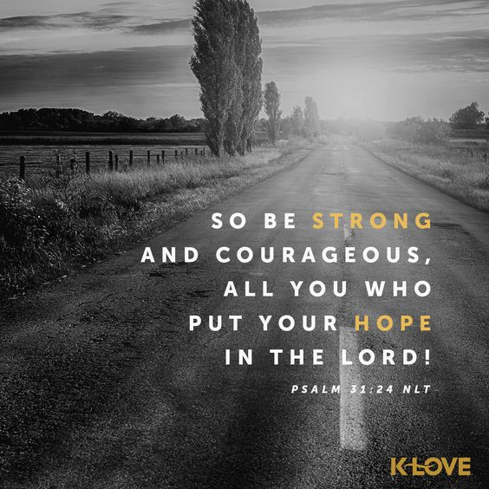
God’s great warriors: Esther
Today we are going to look at another of Gods great warriors; Esther. Esther was a young Jewish girl; she didn’t have training and education in order to rule a kingdom, nor skills to fight a war, but she was faithful and obedient and trusted that God was in control.

Story

Use your kid’s bible to tell the story or watch one of the links below:

https://www.youtube.com/watch?v=SaS_ePAjCvk&list=PLBJuK6cICI17zZpF7dF4m5OomCTPTSRHb (Age 6 plus)

https://www.youtube.com/watch?v=GqO6O0jiBM4 (Age 3 plus)

Sometimes it’s scary to stand up for what is right. In this story Esther knew that she wasn’t a powerful person. She understood her place as the Queen was to obey the King, she knew that by standing up for her people she could lose her life, but she trusted God and knew that without standing up and being brave God’s people would be harmed.

Just for a fun recap: https://www.youtube.com/watch?v=qXv1ImfILOs

Craft: Make a crown

You will need:
- Card
- Colouring pens
- Glue
- Sticky tape
- Coloured paper, stickers, gems, glitter, sequins- Anything you want to decorate your crown

Measure your child’s head and cut card to the correct length required. You will most likely need to tape too strips together.
Cut triangles into the top of the strip to make crown shape.
Stick or colour any decorations that your child wants.
Tape crown into a circle to fit your child’s head.

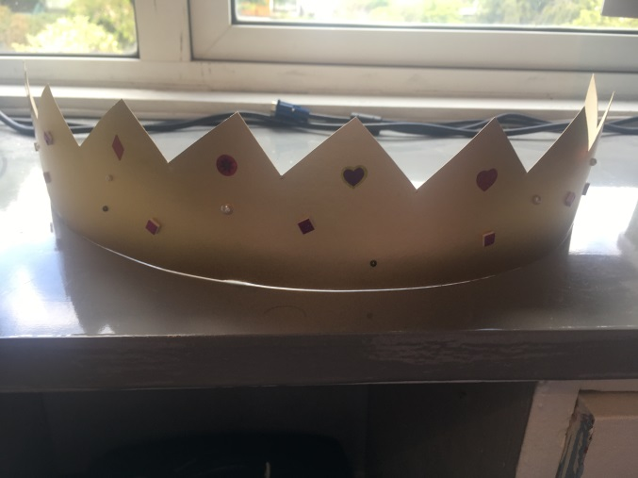

While you make the crown talk to your child about God’s purpose for them. Esther didn’t know it but she was chosen by God to wear that crown and become Queen so that she could save his people. Let them know that God’s got a great plan for them. It may not be to become a Queen and save the world, it may be to look after someone at school who needs a friend or to give food to someone who is hungry. Can they think of something that they can do to help someone else?

Prayer
Listen to ‘You make me Brave’ https://www.youtube.com/watch?v=mjcI72P72A8
Pray that God will use you to help others. Ask him to make you brave when you need to be. Thank God that no matter the situation he’s with you.

Worship fun
Get your dancing shoes on and lets praise…………..
- Brave by Design (Audacious kids): https://www.youtube.com/watch?v=wNrPl0P_dSs

- You make me Brave (Bethel Kids)
https://www.youtube.com/watch?v=mjcI72P72A8

- Undefeated (Elevation kids):
https://www.youtube.com/watch?v=jjt7gEL7Lhk

