HORIZON FUN AT HOME
Sunday 10th May 2020
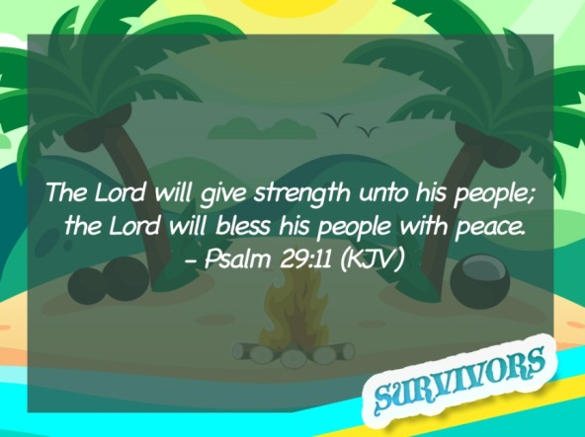
Gods great warriors: David
A few weeks ago we looked at faith. Which God said is:
Putting our confidence and hope in him.

We’ve all needed to do that during this time when things are different and we don’t always know what will happen next.

Over the next few weeks we are going to look at ‘God’s great warriors’. These are people who had faith in extreme circumstances. They weren’t all soldiers trained to go into battle or clever people who had the right qualification to cure the entire world’s illness. What they did have was Faith and a love for God.

Story
Use your children’s bible to tell the story of David and Goliath or watch:

https://www.youtube.com/watch?v=_re3b3UzbVg (Kids aged 6 plus)
https://www.youtube.com/watch?v=2gqi7D7QiZg (3+)

Game:
- Draw a picture of a face on a piece of paper (this will be Goliath).
- Stick the picture as high up as you can on a wall (indoors or outdoors).
- Screw up 5 pieces of paper.
- Taking 5 turns each, challenge each other to see who can hit Goliath in the head.

Back to the story……
Psalm 29:11 says
The Lord will give strength unto his people;
The Lord will bless his people with peace.

David was probably a little scared, but he knew Gods peace and knew that the strength to defeat Goliath would be given to him by God.
He may not have been trained in war like his brothers and the King, but God had trained him in fields as he looked after his Fathers sheep. He learnt the skill of a sling shot while defeating wild animals, and he learnt to trust and have faith in God by spending time praying and listening to God while alone in the fields.

God gives us opportunities to learn in our everyday life, at school, at home, wherever we are. We may not need to learn to fight or throw a sling shot like David, but God may teach us to be kind and patient. Or he may give you a skill to make things. We never know when these things can be used to do Gods work. Spend time with God and get to know him, your faith will grow and when the time comes to be brave you will know Gods got your back!

Craft: David and Goliath toilet roll figures

You will need:
3 Toilet rolls
Coloured pens
Paper
Tape
Anything else you wish to stick on e.g. foil, card….
Pipe cleaners/straws or other

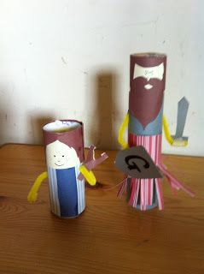

Stick two toilet rolls together to make Goliath. Cut lines into a piece of paper to create a fringe effect. You can colour this if you like. Wrap around bottom on Goliath and tape into place. Wrap pipe cleaner around back of toiler rolls and bend each end toward the front, then tape in place. Now decorate them with clothes and faces as you like. You can also add extras like swords and sling shots from card and decorate with foil.
Just for Fun Facts:
- People trained to use a sling shot were called Slingers.
- Slingers were really, really, really good with this simple weapon.
- Most Slingers could hit a target 200 yards away with a stone from their slingshot. That means they could hit a target 2 football fields away from them. That is a LONG WAY.
- Many slingers could hit a bird…in flight.
- The stones in the valley of Elah where David faced Goliath were special. They were made of barium sulphate which means they were twice as dense as normal stones. Ouch!
- A rock from a slingshot typically flew at 35 metres per second!
- The rock from David’s sling had the stopping power of a handgun!

Prayer
Thank God that he’s got your back and is looking after us during this time. Pray that he gives you strength when you need it.
(Remember when we pray we are building our relationship with God)

Worship fun
Get your dancing shoes on and lets praise…………..
- Brave by Design (Audacious kids): https://www.youtube.com/watch?v=wNrPl0P_dSs

- Jesus you’re my Superhero (Hillsongs Kids):
https://www.youtube.com/watch?v=U7-pQrQBI_k

- Undefeated (Elevation kids):
https://www.youtube.com/watch?v=jjt7gEL7Lhk

